**44-542 Object Oriented Programming**

**Introduction to Java**

Follow the instructions below to write a Java program to display your name in a box. For example, your output might look like this:

**+------+**

**| Ajay |**

**+------+**

1. Open NetBeans, and close the **Welcome** screen.
2. From the **File** menu, select **New Project…**
3. Under **Categories**, select **Java**.
4. Under **Projects**, select **Java Application**.
5. Click **Next**.
6. Enter your last name as the project name with the first letter capitalized.
7. For **Project Location**, choose the location you prefer. This is your NetBeans workspace and will contain the files you add to your project as well as other files that the IDE provides.
8. Uncheck the checkbox for **Create Main Class**. You can have Java create this class for you automatically by leaving this checkbox checked, but for this worksheet we will show you how to create the main class yourself.
9. Check the checkbox for **Set as Main Project**.
10. Click **Finish**.
11. Find your project in the **Projects** window. If you can’t see the **Projects** window, open **Window** from the menu bar and click on **Projects**.

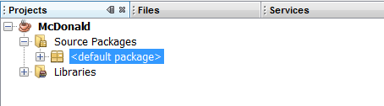

1. Expand **Source Packages** in your project. Right click on **<default package>**, select **New**, then select **Java Main Class…** You will see a warning at the bottom of the window that tells you it is recommended that you NOT place classes in the default package. Most of the time we will heed that warning, but for this short example, we will use the default package.
2. Enter **PrintNameBox** as the name of the class. Be sure to use exactly the same capitalization as shown here for project and class names.
3. Click **Finish**.
4. Find the **@author** annotation near the top of the file and replace the s-number with your first and last name.

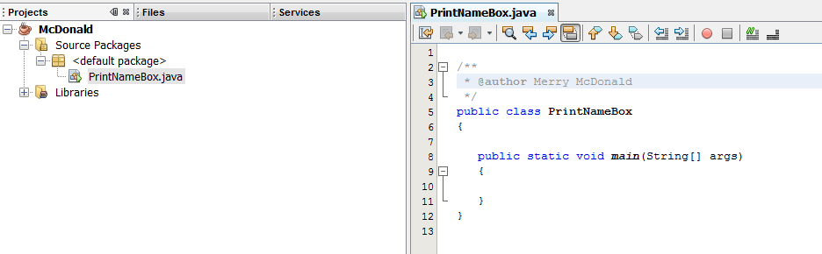

1. Add code to the **main** method that displays your name in a box like the one shown at the beginning of this document. This can be done with three println statements.
   * Be precise! The box you use must look exactly like the box shown at the beginning of this document, except that it may be wider, depending on the length of your name.
   * The number of hypens (-) must be exactly two more than then length of your name.
   * The corners of the box must be denoted using a plus (+) sign.
   * Each side of the box must contain a single vertical line, in addition to the two plus signs on the corners.
2. Click on the **Save all files** button () near the left corner of the screen
3. In the **Projects** window, be sure the project you created (named using your name) is highlighted.
4. You can run your project in either of two ways:
   * Click on **Run** on the menu bar, and choose **Run Main Project (F6)**.
   * On the toolbar, click on the **Run Major Project** icon. It looks like this: 
5. Your output should appear in the **Output** window at the bottom of the screen.
6. Note: There are also icons for building a project () and for cleaning and building a project (). If you make changes to your program and don’t see these changes reflected when you execute the program, you might try cleaning and rebuilding the project.